
DAWOOD UNIVERSITY OF ENGINEERING AND TECHNOLOGY
M.A JINNAH ROAD KARACHI-74800 (PAKISTAN)

FACULTY OF INFORMATION SCIENCES & HUMANITES
DEPARTMENT OF ARTIFICIAL INTELLIGENCE

Title: Project Report (Computer Vision)

Submitted by:

23-AI-57
23-AI-81
23-AI-03
23-AI-49

Submitted to:

Engr. Hamza Farooqi
Lecturer
Department of Artificial Intelligence

Smart Surveillance & Crowd Analytics System

1. How to Run the System
1. Prerequisites
- Install Dependencies: pip install opencv-python numpy matplotlib ultralytics pyttsx3
2. File Preparation
- Place your source video (e.g., crowd.mp4) in the same folder as your Python script.
- Open the script and ensure the video_path variable matches your filename.
- If needed, modify the MOVE_X and MOVE_Y variables to position the surveillance zone over your desired area.
3. Execution
- On the first run, the system will automatically generate the overcrowded_alert.wav file using the text-to-speech engine if it doesn't already exist.
- A window titled "Surveillance Feed" will appear, showing the live processing.
- To stop do not close the window. Instead, press the 'q' key on your keyboard while the video window is active. This ensures the program saves the output video and generates the final analytics plot correctly.
4. Reviewing Outputs
Once the program finishes, check your project folder for:
- output_surveillance.mp4: The fully annotated video with bounding boxes and alerts.
- density_plot.png: A graph showing crowd density trends over time.
- scene_structure_edges.jpg: An edge-detected map of the first frame for structural reference.

2. Pipeline Architecture Diagram
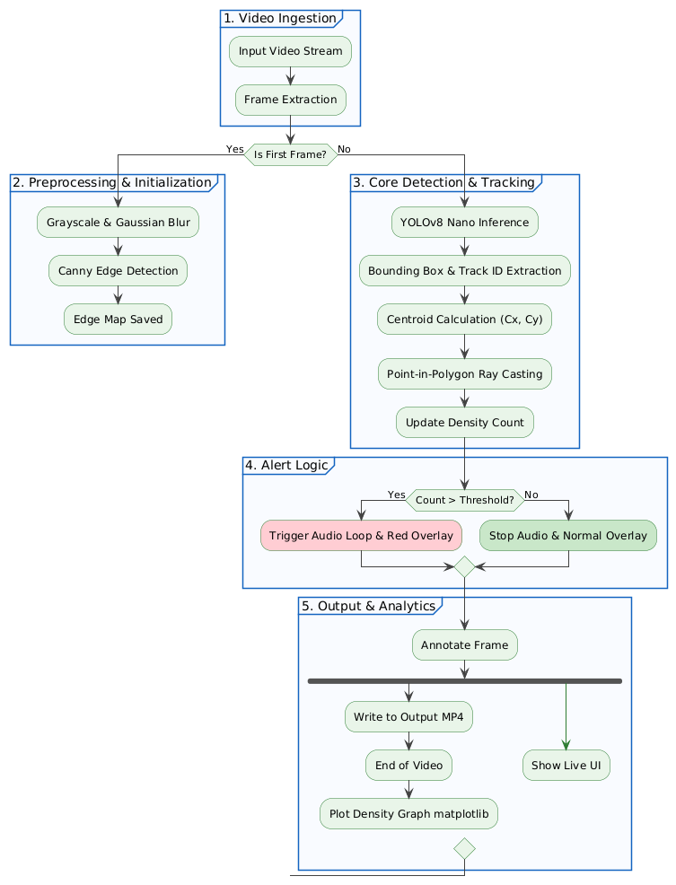

3. Methodology
Phase 1: System Initialization and Preprocessing
Before continuous monitoring begins, the system must establish the physical constraints of the camera’s field of view.
- Video Ingestion: The video stream (cv2.VideoCapture) is initialized, extracting the frame width, height, and FPS to ensure the output video matches the source quality.
- Structural Mapping (Morphological Preprocessing): A single sample frame is captured and converted to grayscale. A Gaussian Blur is applied to reduce high-frequency background noise. Subsequently, a Canny Edge Detector isolates physical boundaries (e.g., walls, walkways). This structural map is saved independently to assist the human operator in defining accurate surveillance zones.
- Zone Definition: A customized polygonal Region of Interest (ROI) is defined using a multi-dimensional numpy array, representing the restricted area where density will be monitored.
Phase 2: Deep Learning Detection & Tracking
The core analytical engine processes the continuous video feed frame-by-frame.
- Inference: Each frame is passed into the YOLOv8 Nano model. The model is explicitly constrained to classes=[0] (the COCO dataset ID for 'Person') to prevent the system from falsely detecting vehicles or background objects.
- Bounding Box Extraction: For every detected person, the model returns spatial coordinates representing the top-left and bottom-right corners of their bounding box.
- Centroid Calculation: The exact center of the individual is mathematically derived using the formula.
- Motion Trailing: Track IDs provided by YOLOv8’s built-in tracker are appended to a historical dictionary, limiting the trail to the last 20 frames to dynamically render movement paths without cluttering the screen.
Phase 3: Spatial Logic and Intrusion Assessment
Once targets are identified and tracked, the system determines their relationship to the restricted zone.
- Ray-Casting Algorithm: OpenCV’s pointPolygonTest function is executed against each person's centroid coordinates. This mathematical operation checks if the centroid vector falls within the bounds of the customized ROI polygon.
- Density Aggregation: If the algorithm returns a value indicating the person is inside or exactly on the boundary of the zone, the active people_in_zone integer is incremented for that specific frame.
- Data Logging: The final count for the frame is appended to a density_data list for post-processing analytics.
Phase 4: Asynchronous Alert Mechanism
To handle overcrowding without interrupting the video feed's real-time performance, a non-blocking alert architecture was implemented.
- Threshold Evaluation: The current density count is continuously compared against a predefined CROWD_THRESHOLD.
- Visual Feedback: If the threshold is exceeded, the polygon overlay color dynamically shifts to red, and an emergency text overlay is drawn onto the frame.
- Audio State Machine: A boolean flag (alarm_is_playing) controls the audio state. When the threshold is crossed, a pre-generated .wav audio file ("Overcrowded") is triggered using the winsound library. This ensures the alarm loops continuously in the background without freezing the frame rendering. Once the density drops below the threshold, a command instantly halts the audio.
Phase 5: Output Generation and Analytics
- Video Assembly: The fully annotated frames—containing bounding boxes, motion trails, custom zones, and density text—are written sequentially into an output .mp4 file via cv2.VideoWriter.
- Data Visualization: Upon system termination, the density_data array is passed to matplotlib.pyplot to generate a line graph charting crowd density over time, providing administrators with historical insights into peak crowding events.
4. Challenges Faced and Suggested Improvements
Primary Challenges:
- Thread Blocking with Audio: Initially, triggering the crowd alert caused the video processing loop to freeze until the audio file finished playing. This was resolved by implementing asynchronous audio playback using Windows' native looping functions, allowing continuous frame rendering while the alarm triggers.
- Occlusion in Dense Crowds: In highly congested frames, individuals in the foreground frequently overlapped and obscured individuals in the background. Because the system relies on a 2D bounding box, severe occlusion resulted in merged bounding boxes and slight undercounting.
- Depth Perception: The point-in-polygon logic relies strictly on 2D $(x, y)$ pixel coordinates. Due to the camera angle, a person's upper body could physically appear inside the designated 2D polygon on the screen, while their feet were standing outside of the actual physical zone.
Suggested Improvements:
Future iterations of this system would benefit from implementing a Homography Matrix. By mapping the camera's perspective to a flat, 2D "Bird's Eye View" (Top-Down) grid, the centroid coordinates could be projected accurately. This would entirely solve the depth perception issue and allow for distance calculation between individuals to measure exact physical crowding density per square meter.

